GUI Concepts

In computing, graphical user interface (GUI, sometimes pronounced "gooey" or "gwee") is a type of user interface that allows users to interact with electronic devices through graphical icons and visual indicators such as secondary notation, as opposed to text-based interfaces, typed command labels or text navigation. GUIs were introduced in reaction to the perceived steep learning curve of command-line interfaces (CLI), which require commands to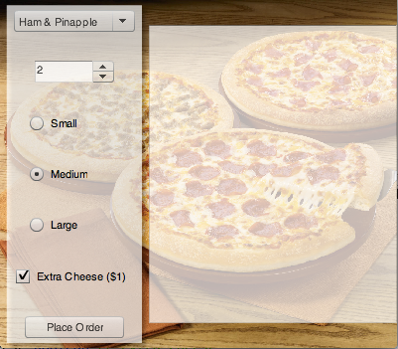 be typed on the keyboard.

This is a stepper which is used to determine how many pizzas the user would like to add to an order.

A stepper is used to increment up or down a numerical value to a maximum and a minimum set by the programmer.

This is a set of radio buttons, this is used to let the user select a pizza size for his/her order.

Radio Buttons are used when the user may only select one option out of a select few.

This is a button and it is pressed by the user when he/she completes filling in their order.

In the program this activates an event/function/method that processes the above information inputted by the user.

The person that invented the idea of a GUI was Doug Engelbart. His work later went on the create the world’s first computer with a GUI which was made by a company called Xerox PARC in Palo Alto.

The GUIs made computers almost infinitely more usable to the average Joe and children, because before the GUI the only interface a computer had was its command line. Now that there is a GUI more people use computers and get more work done.

This is a drop down menu and is where the user selects the pizza he/she would like to order.

Dropdown menus are usually used when there are more than 5 items in a list that a user must select from.

This is a check box which is used to give the user the option to order with extra cheese.

This is a simple visual tick box which returns a True or False value in the program.

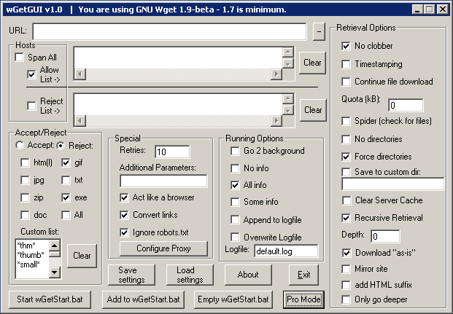

Very crowded UI, no clear flow for the user to follow, too much information in one page, too many options on screen.